
SPG290 CD Development Guide V1.0

02/27/2006

Table of Content
1 Table of Content 2
2 Revision History 3
3 The Limitation of the CD Driver 4
3.1 CD Type Support 4
3.2 File System 4
3.3 Burn the CD-ROM 4
4 API introduction 8
4.1 init_cdrom 8
4.2 iso_open 8
4.3 iso_close 8
4.4 iso_read 8
4.5 iso_lseek 9
4.6 Servo_Stop 9

Revision History

Revision | Date | By | Remark
V1.0 | 2006-02-26 | Simon | First edition

The Limitation of the CD Driver

CD Type Support
- CDDA (Compact Disc-Digital Audio)
Almost all the music CD is using this kind of format.
Data format
2352 bytes data | EDC/ECC | Sub Channel
2352 bytes data | 784 bytes | 98 bytes

- CD-ROM Mode 1
CD-ROM Mode 1 is the exact data format; therefore it usually used to storage the data. Almost all the software CD-ROM used this data format.
Sync | Header | 2048 bytes data | EDC | Unused | ECC | EDC/ECC | Control channel
12 | 4 | 2048 bytes data | 4 | 8 | 276 | 784 bytes | 98 bytes

- Mixed-Mode CD

Track number | Data format
Track 1 | Data Track
Track 2 | Audio Track
Track 3 | Audio Track
…Track 99 | Audio Track

File System
Now we only support the standard ISO 9660 not support the UDF file system. And about the filename, we support to ISO2 level (the maximum character number is 31), but not support Joliet. The character of the filename must be A~Z, 0~9 and _.

Burn the CD-ROM
According the limitation of the CD-ROM driver, what process to burn the cd-rom that can be read by SPG290 is an important thing. In this section, we use software which called NERO to introduce the process.

Step 1. New a project
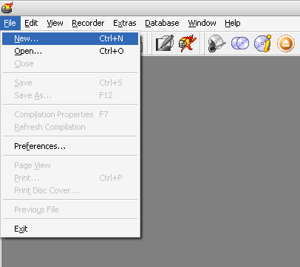

Step 2. Choose CD-ROM (ISO) and No Multi-session
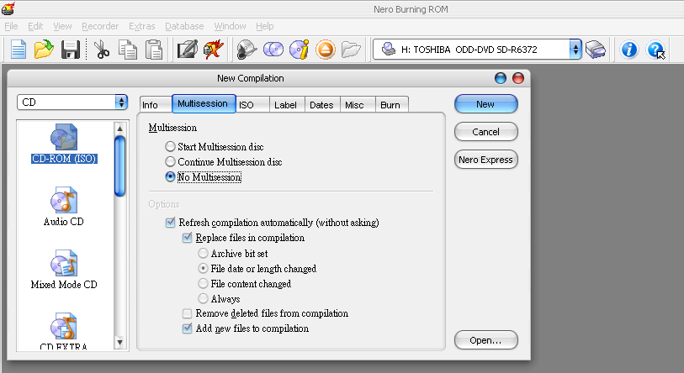

Step 3. File system setting
ISO Level 1 and ISO Level 2 can be set also
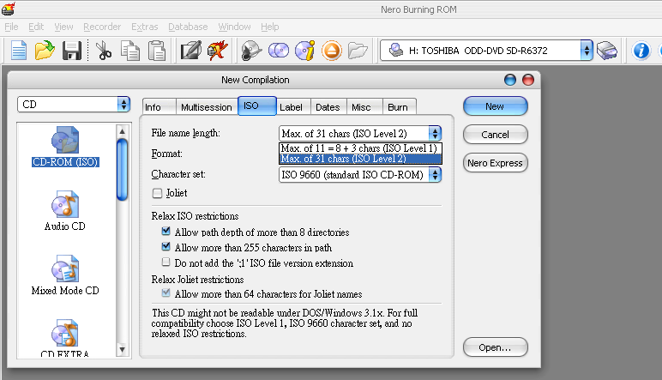

Format set to Mode 1
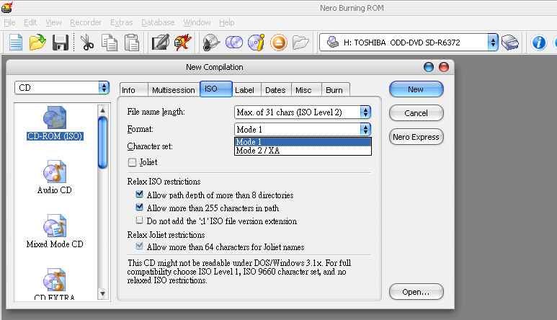

Character set: ISO9660 (standard ISO CD-ROM)
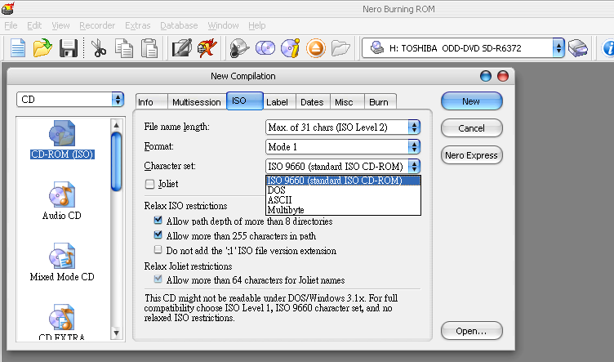

Joliet can no be set
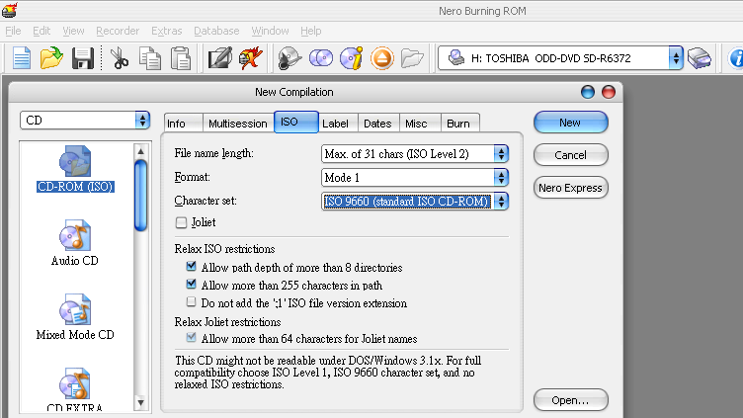

Finalize CD (No further writing possible!) and the write method is Disc-at-once
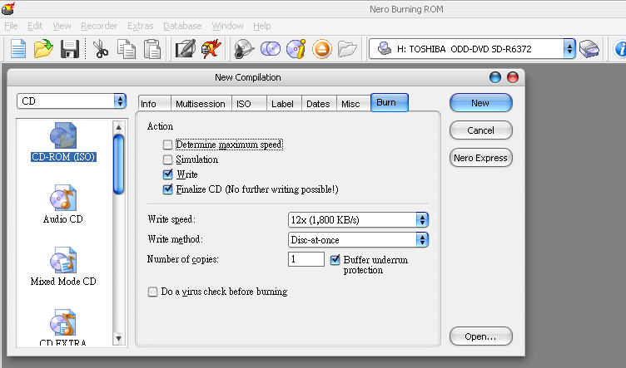

API introduction

Init_cdrom
Initial the CD system including SPG290 and Servo.
Void Init_cdrom(int ringbuffer_low, int ringbuffer_high)
parameter
It must have a ring buffer to storage the data from CD_ROM. In this function, the begin of the ring buffer and the end of the ring buffer must to be set.

iso_open
Open the specified file with the specified operation mode.
int iso_open (char *filename)
parameter
filename
Pointer of the path name string. For example: SPG290\\example.txt, SPG290 is the folder

Return Values
The normal return value from open is a non-negative integer file descriptor. In the case of an error, a value of -1 is returned instead. NOTE: Return value is a file node index. Maybe zero.

iso_close
Close the file specified by the file node index.
int close (int filedes)
Parameter
filedes
File node index, maybe it’s “open” return value.
Return values
The normal return value from close is 0; a value of -1 is returned in case of failure.

iso_read
Read bytes from the file specified by a file node index.
int iso_read (int filedes, void * buffer, unsigned int size)
Parameter
filedes
File node index, it should be a return value of open function.
buffer
Buffer pointer. It’s data pointer given to specify an offset in the DRAM.
size
Reads up to size bytes from the file.
Return values
The return value is the number of bytes actually read. This might be less than size; In case of an error, read returns -1.

iso_lseek
Set the read-write pointer position of the file specified by the file node index.
int iso_lseek (int fd, long offset, int whence)
Parameter
fd
Index of the file node.
offset
The offset will be set.
whence
Value | Description
SEEK_SET | Sets the file pointer to the value of the offset parameter.
SEEK_CUR | Sets the file pointer to its current location plus the value of the offset parameter.
SEEK_END | Sets the file pointer to the size of the file plus the value of the offset parameter.
Return values
The return value from lseek is normally the resulting file position, measured in bytes from the beginning of the file. You can use this feature together with SEEK_CUR to read the current file position. If the file position cannot be changed, or the operation is in some way invalid, lseek returns a value of -1.

Servo_Stop
Stop the Servo and spindle

How to integrate the library
Step 1:
Add the library in the project, including the CDDrv_lib1x.a and servo_lib.a

Step 2:
Setting a timer 1ms to do the things like below.
void IRQ56(void)
{
static int counter = 0;

cddsp_polling();
counter+=1;
SERVO_TimerCountDown();
if( counter == 5 )
{
SERVO_Exec();
counter = 0;
}
*P_TM0_CTRL = TIMER_ON | TIMER_IRQ_ON | TIMER_IRQ_CLR;
}

